Week 1 Homework

100 Points Total

**Due date:** Start of class on Friday, 8 Sept 2017

**Name: Josh Howard_____________________**

**Part 1:** Honesty Statement:

I Josh Howard_________________ [Insert your name] agree that I will complete this assignment **without** the aide of another student. I understand that I **may** use any course notes that I have taken, any available course material on blackboard and other reference materials, such as the Internet or computer science texts. I understand that I can also seek professional assistance, such as the Instructor or tutoring lab assistants, but will attempt the assignment on my own first.

**Part 2:** Define the following terms with regards to computer technology. [2 pts each]

1. Main Memory – The volatile memory the CPU will use while processing.
2. Second Memory – The non-volatile memory that is used for Data storage.
3. BIOS –The firmware on a motherboard initializing the hardware, checking for their health and gives control to the main system afterwards.
4. Motherboard – A circuit board that contains all of the components of a computer.
5. Register – Part of the CPU that holds small sets of data for use.

**Part 3:** Name the 3 major **components of the CPU** and explain the function of each: [2 pts each]

1.Control Unit: Tells different computer components how to respond to a programs instructions.

2.ALU: Performs all of the logical operations.

3.Registers: Holds data, such as instructions, storage address or other kinds of data.

**Part 4:** Name 3 **input** devices and explain the function of each: [2 pts each]

1.Mouse: Allows the user to move a cursor around a computer screen.

2.Scanner: Scan’s physical documents as digital images to score on a computer

3.Microphone: Allows audio to be picked up on a computer.

**Part 5:** Name 3 **output** devices and explain the function of each: [2 pts each]

1.Monitor: Displays computer info the user can interact with.

2.Printer: Prints out digital images or documents to a physical form.

3.Speakers: Allows digital audio to be played and heard by a user.

**Part 6:** Short Answer [1 pt each]

1. Thinking about their internal power, but the plug going into the wall, do electronics operate from AC or DC current? ____DC______
2. Can a CPU contain more than 1 ALU? ______Yes__________
3. Main memory is also known as RAM or ROM? __RAM_____
4. Data currently located in RAM is still there when the power goes off and comes back on? YES or NO _NO_

**Part 7:** Of the multiple videos linked in the 30 Aug 2017 Class Presentation, watch 3 and write a paragraph each about the content of the video, such as what you learned, what you found interesting, what you want to know more about, etc. [10 pts each]

Name of Video 1: ________________________How a CPU Works______________

This video shows the different part’s within the CPU. Along with that, it shows how the CPU works with each components on the motherboard. Something I learned is how exactly the CPU works together with each component and what kind of info is passed between each one.

Name of Video 2: ____Transistors - The Invention That Changed The World_______

The video shows the brief history of the transistor where they started as the vacuum tube and where they’re at now. It also shows why they’re made out of silicon today and how they work. What I learned was why current transistors are made out of silicon and how exactly they work using binary.

Name of Video 3: _____________________________________________________

**Part 8:** Briefly state (minimum of 5 sentences) why computer components and computer circuitry is susceptible to heating issues? Name two modern advances in technology created to deal with those issues? [10 pts]

When computer components are in used, they generate heat. That excess heat can damage components by melting them, un-soldering connections if they get too odd, push too much electricity through component and overload it (which creates even more heat), and many more. As the technology advances throughout time, we need better and more effective methods of removing that heat. One popular method today is air cooling. A metal heatsink with a fan is attached to the CPU. The fan pushes or pulls air through that heatsink, removing the heat. Another way is liquid cooling. Liquid cooling uses water or a non-conductive liquid that will gather the heat as it passes over the CPU and bring it to a radiator that then cools the liquid back down.

**Part 9:** Conduct research and in your own words, describe why some people prefer an AMD processor over an Intel processor and vice versa. You must find (and state) supporting arguments in favor of each processor. Minimum of 2 paragraphs. Cite your sources. [15 pts]

Right now, the AMD vs Intel debate is in a very interesting period. The debate used to be that Intel was the go to manufacturer of high-end chips, if you had the extra money to spend on them. Those high-end chips would beat AMD chips in both gaming benchmarks and single-threaded applications. Here, (<http://www.pcgamer.com/gaming-performance-of-ryzen-7-vs-core-i7-with-geforce-gtx-1080-ti/>) you can see that the Intel i7-5930k is beating the AMD Ryzen 7 1700 chip in almost every gaming benchmark. The main argument though for AMD chips though is the price. Though AMD chips don’t do as good as Intel chips in Gaming and Single-thread performance, they are a good bit cheaper and “close enough.” The “good enough” is that, if you look at the benchmarks previously linked, the Ryzen 7 chip is right there no too far behind the Intel chip. That price for that performance though being only $329 (<https://www.newegg.com/Product/Product.aspx?Item=N82E16819113428&cm_re=ryzen7-_-19-113-428-_-Product>), vs the $638 price point for the Intel i7.

Now though, because of the new AMD line up of their new Threadripper CPUs, the game has changed in favor of AMD. In the benchmarks here (<https://arstechnica.com/gadgets/2017/08/amd-threadripper-review-1950x-1920x/>), you can see that the Threadripper lineup beats intel’s top consumer chips fairly well. Using the TR 1950x and the I7-6950x as examples. The Threadripper CPU beats the I7-6905x in everything but the single thread benchmark, but the key here is the price. The i7 chip is priced at $1730 (<https://www.newegg.com/Product/Product.aspx?Item=9SIA1UH4M12571&cm_re=i7-6950x-_-19-117-643-_-Product>) while the TR 1950x is only $999 (<https://www.newegg.com/Product/Product.aspx?Item=N82E16819113447&cm_re=1950x-_-19-113-447-_-Product>). So for the performance you get, the 1950x is a far better price/performance chip.

**Part 10:** Identify the following computer components by writing the name of the component by the number below. [1 pt each]

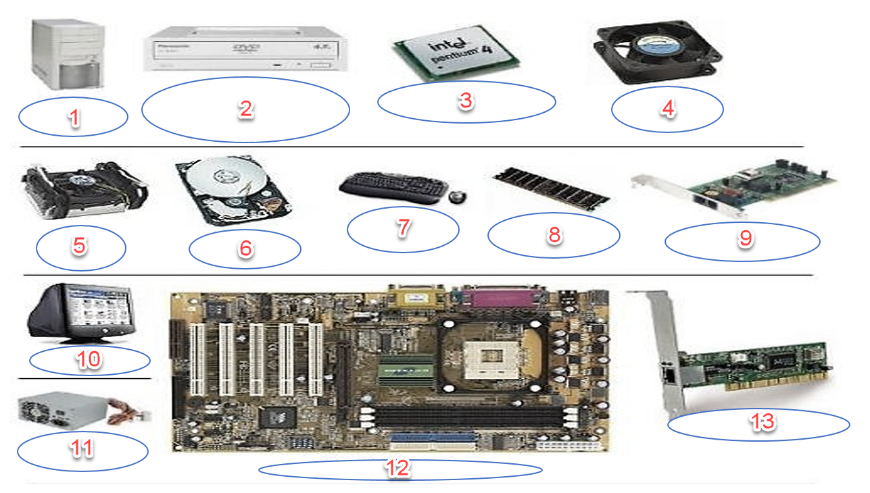

Write/type the name of the components from the above image, next to the corresponding number.

1.PC Case

2.DVD Drive

3.CPU

4.FAN

5.CPU Heatsink

6.Hard Drive

7.Keyboard and Mouse

8.RAM

9.Modem

10.Monitor

11.PSU

12.Motherboard

13.Network card